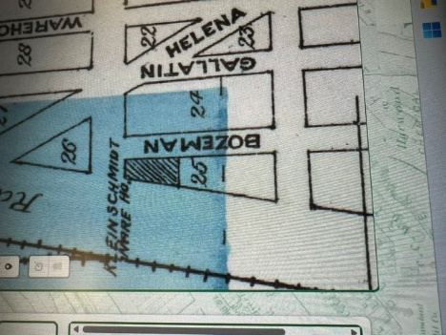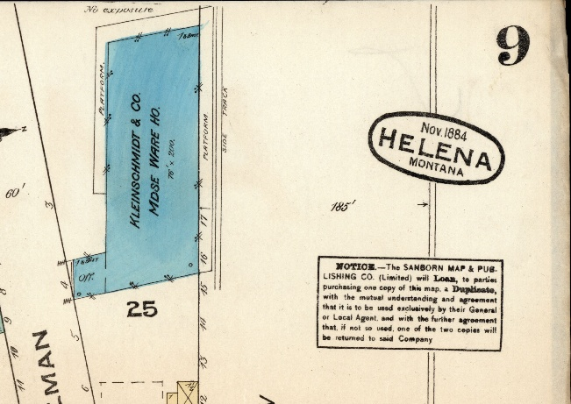
Map 1880 Map 1884
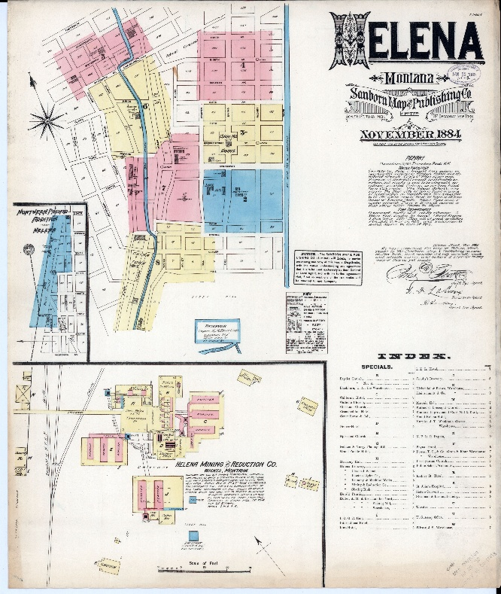
Extended Map 1884

Service Provided by the Kleinschmidt Warehouse in Helena, MT
The Kleinschmidt Warehouse in Helena, Montana, was part of the Kleinschmidt and Brothers business, which operated as a groceries and hardware store from about 1879 to 1896 mhs.libraryhost.com. This enterprise was run by the Kleinschmidt family — notably Theodore H. Kleinschmidt, a prominent Helena businessman — and served the Helena community with a mix of food and household goods.
Groceries would have included staple foods, canned goods, dry goods, and other consumer staples needed by residents, while hardware would have covered tools, building materials, and household supplies. As a local merchant, the store likely catered to both residents and visitors, supporting daily needs and small-scale home improvement projects.
The Kleinschmidt and Brothers business was part of Helena’s broader mercantile and retail sector, which was central to the town’s economy during the late 19th century. The warehouse functioned as a storage and distribution point for these goods, making it a key part of the family’s commercial operations alongside their banking and other business ventures Historic Montana.
In short, the Kleinschmidt Warehouse in Helena provided grocery and hardware retail services to the community, reflecting the family’s role as one of Helena’s leading merchants and financiers.

